**Cloud front& R53 Tasks Assignment**

1. **Configure VPC peering in cross regions.**

* Open AWS console and launch one instance in Europe(Stockholm)

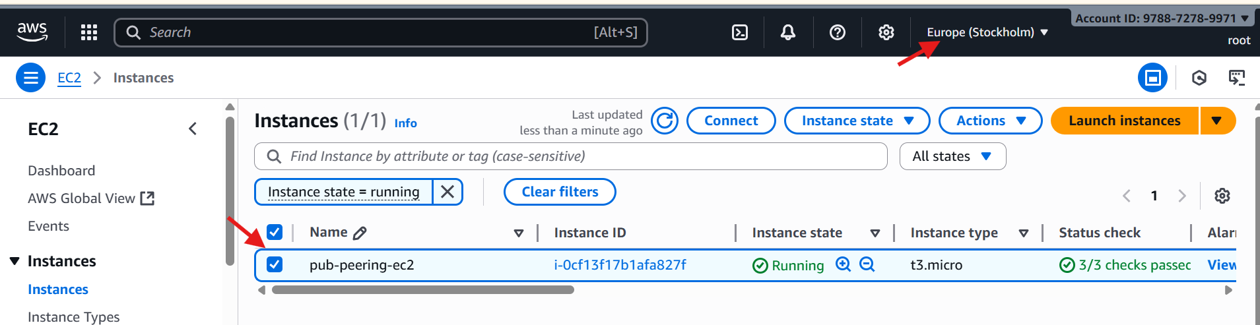

* And duplicate the tab and put the region as mumbai
* Launch one instance in Mumbai region

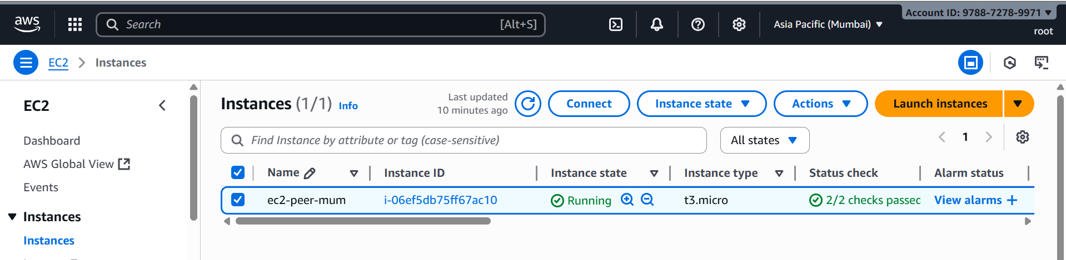

* Go to Europe(Stockholm) region
* Go to vpc and click on peering connection
* Click Create peering connection

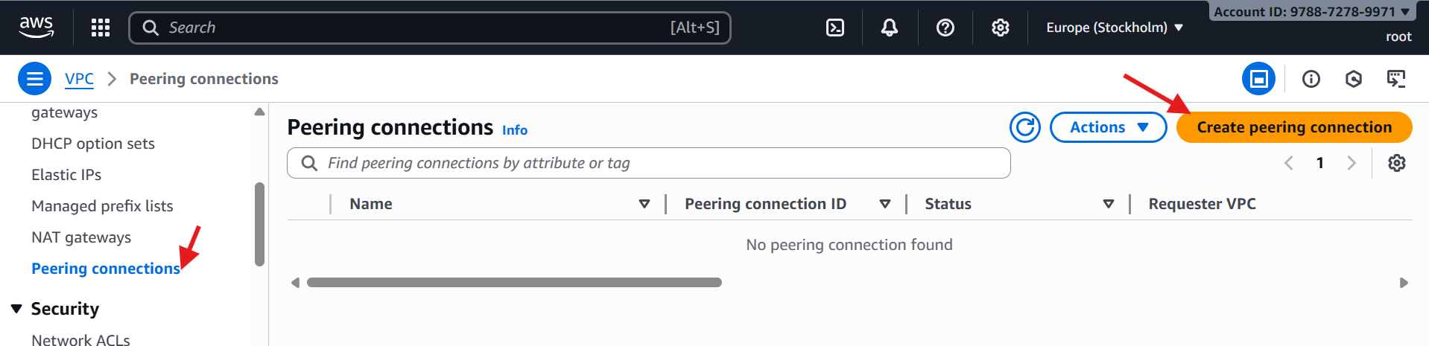

* Give name
* Select your local vpc
* Select another VPC to peer with 🡪 My account 🡪 another region
* Select the region Mumbai
* VPC ID (Accepter) copy the Ohio vpc id and paste
* Click on create peering connection

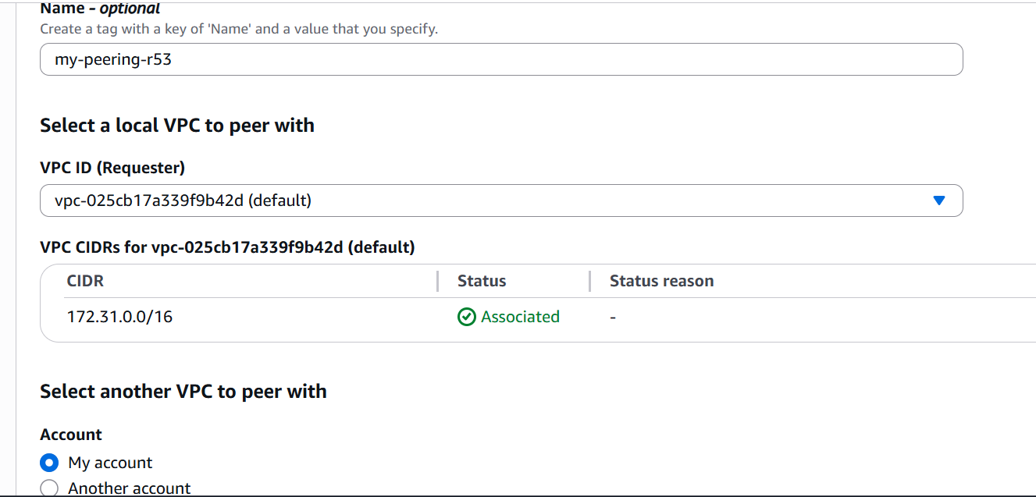

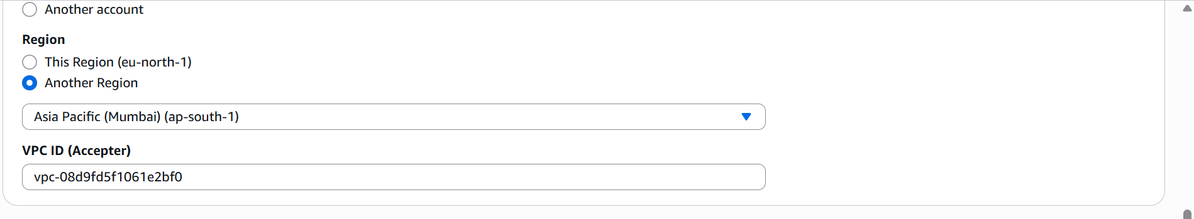

* Peering request has been sent to Mumbai region

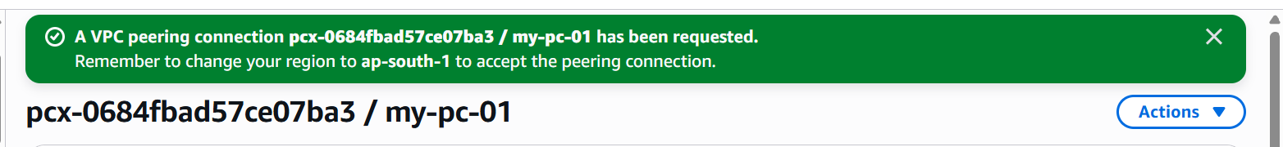

* Go to Mumbai region vpc
* Click on peering connection
* You got one request from another region(Europe)
* Accept the request

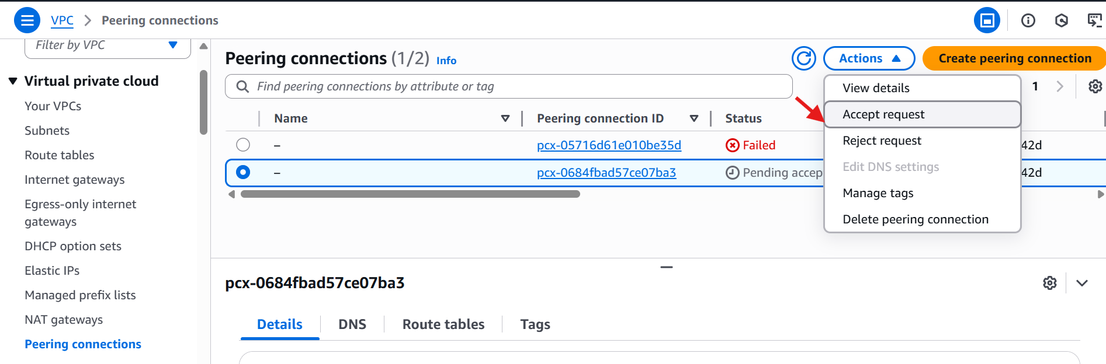

* Here the results

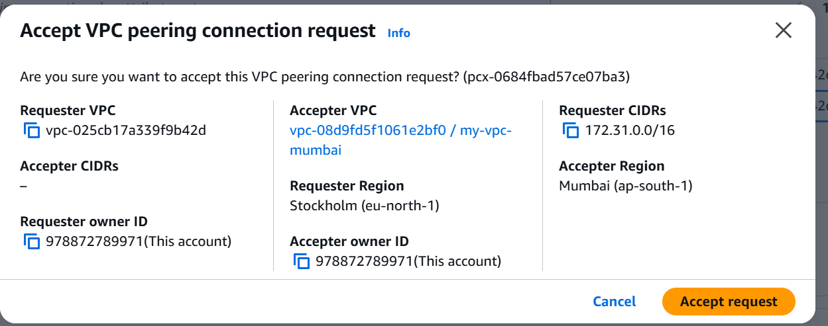

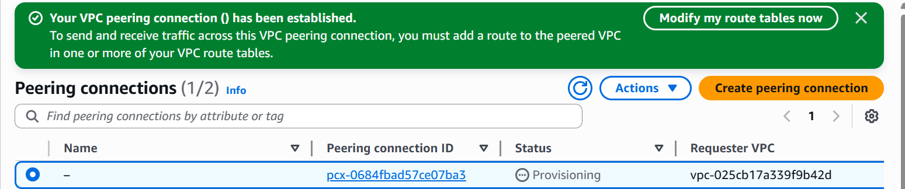

1. **Purchase one domain from Go Daddy.**

* Go to browser and search **Go daddy**
* Click on Go daddy site

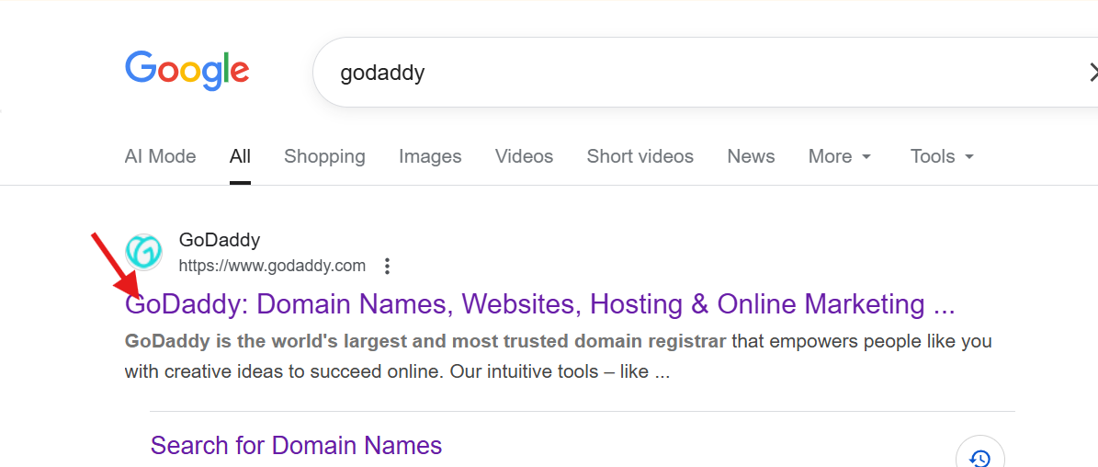

* In search bar search, which domain you want like (.com, .in, .net ...Etc.)
* Choose one domain and click on **make it yours**
* It will take you to the cart
* Click on continue
* Select no **domain protection**
* Disable **create a free website.**
* Click on **continue to cart.**

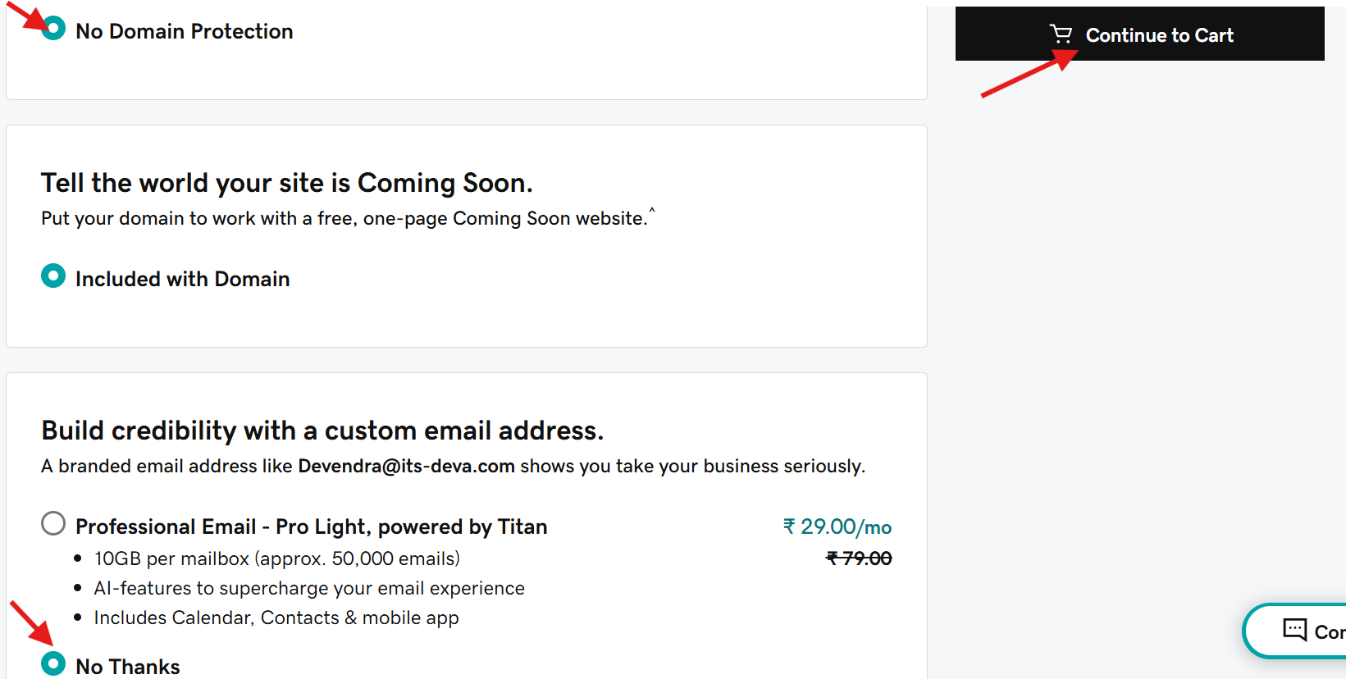

* Select plan for **1 year.**
* Click on **I’m ready to pay.**
* And purchase one domain.

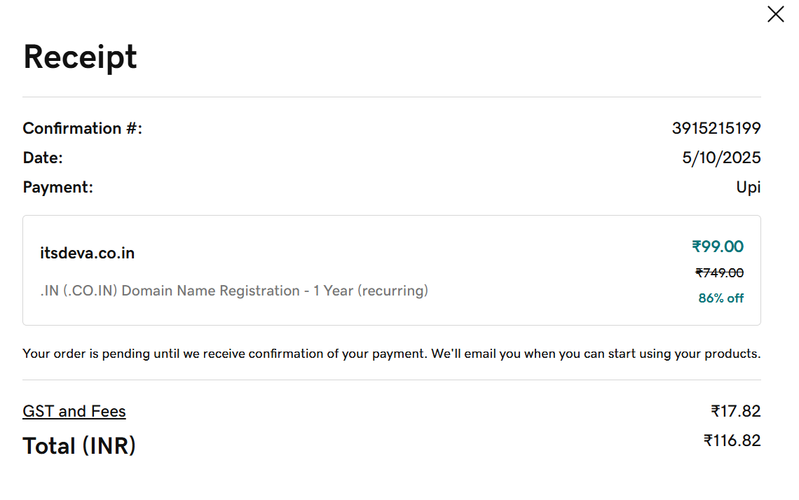

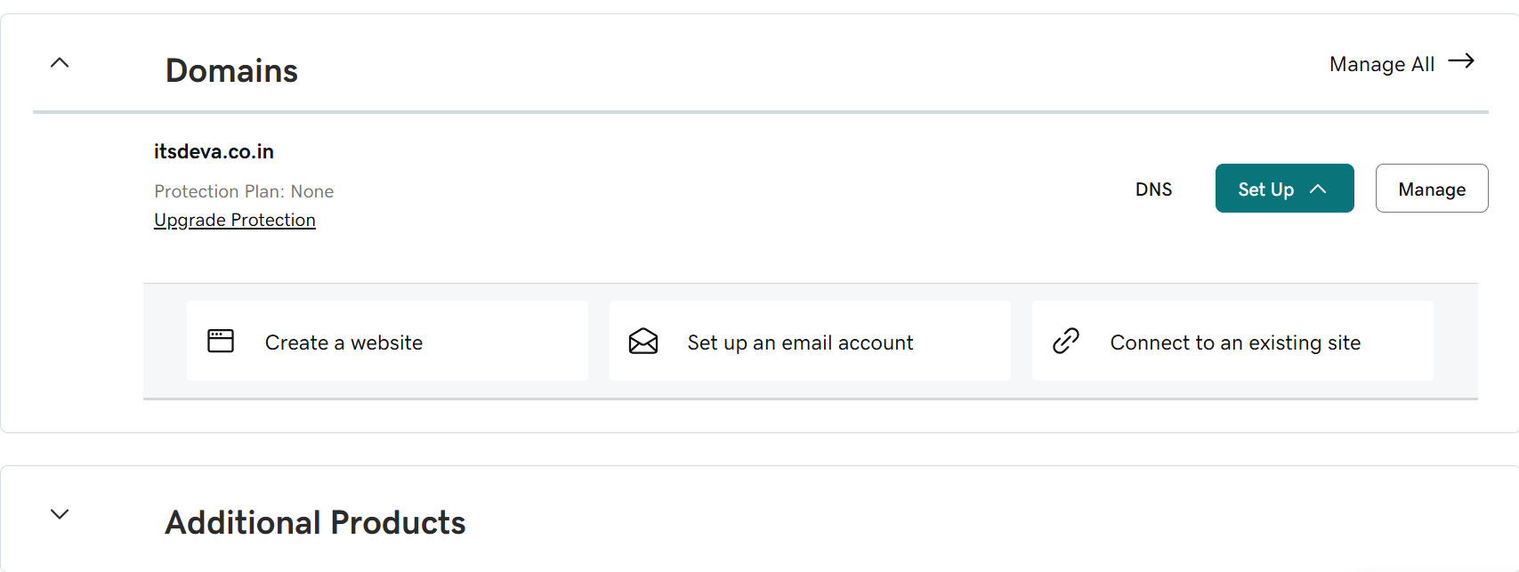

1. **Deploy static website in S3.**
   * Go to AWS S3 service.
   * Click **Create bucket**.
   * Bucket name must be unique
   * Choose the region
   * Keep default options and create

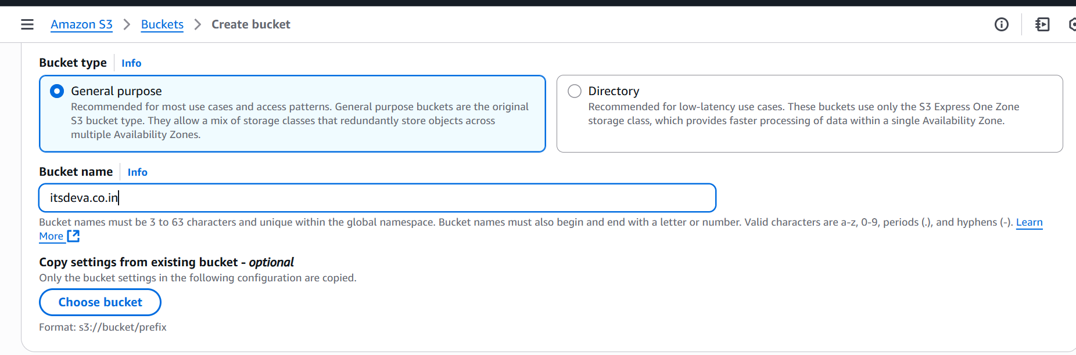

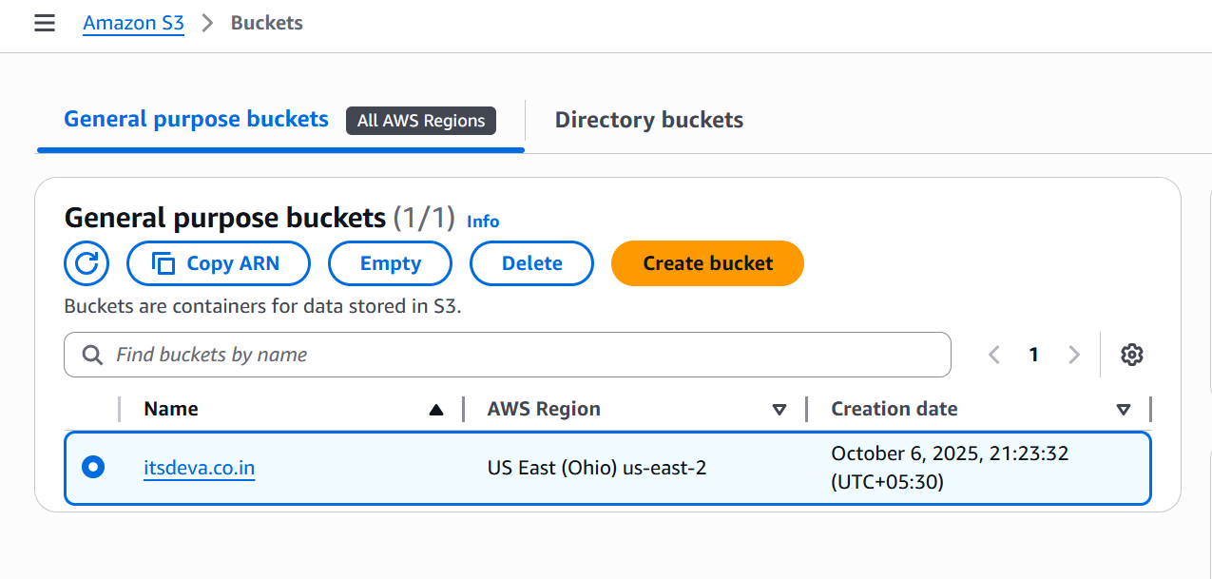

* + Prepare your static website files (for example: index.html, error.html)
* Open your bucket → click **Upload**.
* Add all the files and click **Upload**.

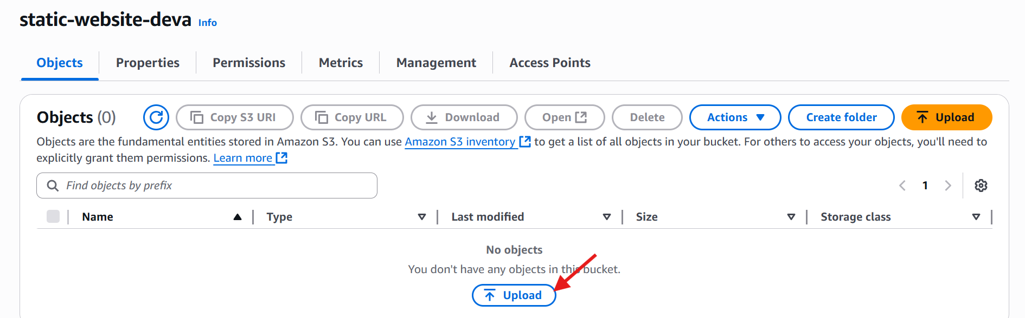

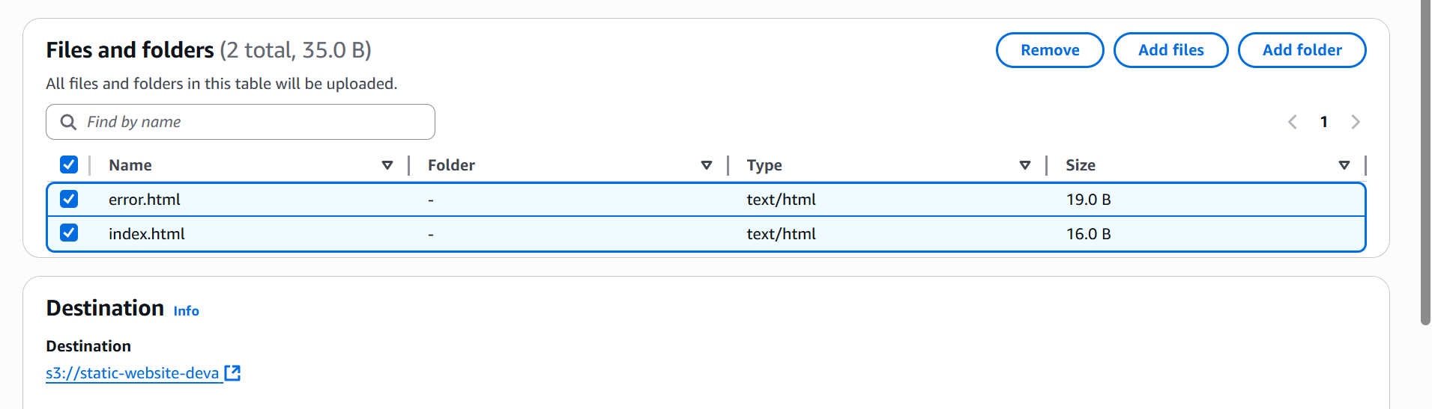

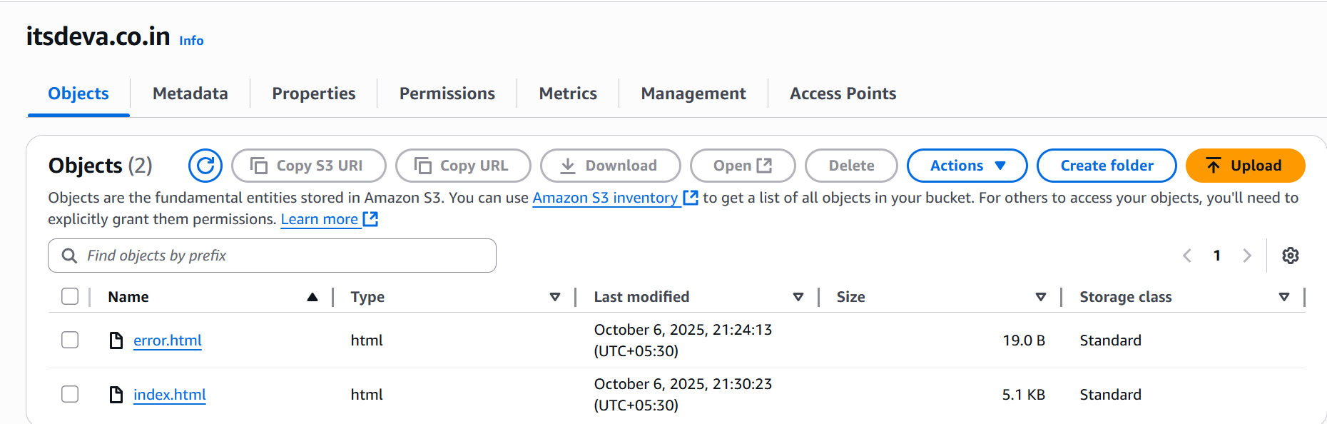

* Open the bucket → go to **Properties** tab.
* Scroll down to **Static website hosting**.
* Enable it → Choose **Host a static website**.
* Enter index.html as **Index document** (and optionally error.html).
* Save changes.

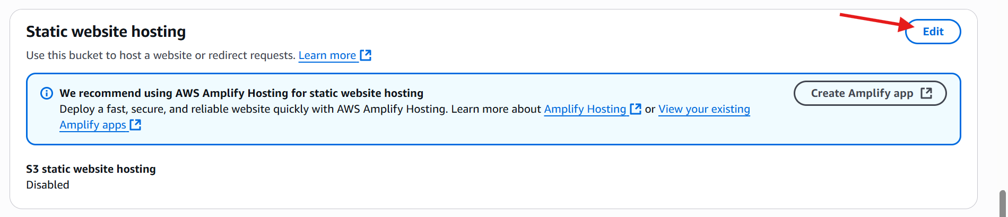

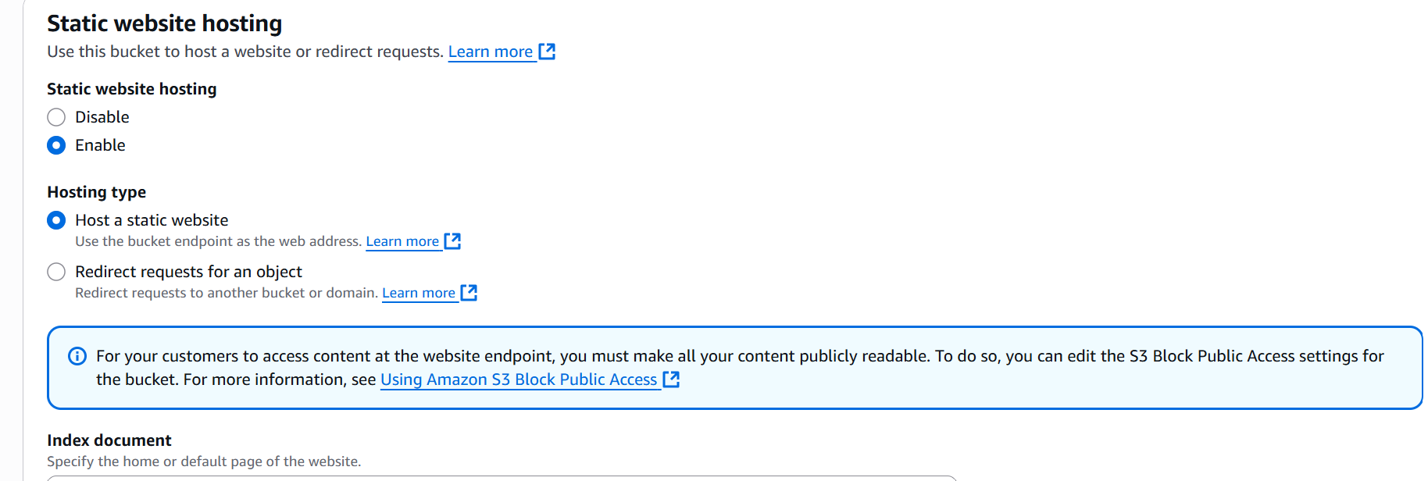

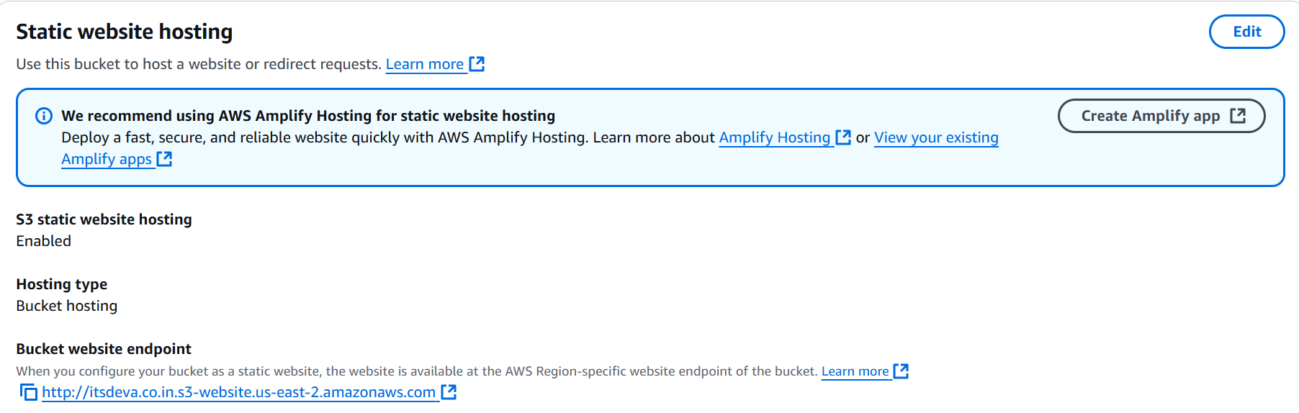

* Copy the URL and paste it in a browser and check.

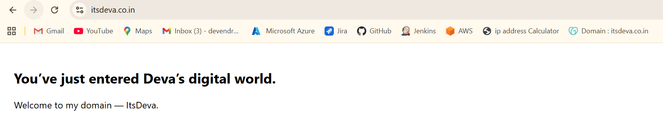

1. **Create a CDN and attach one SSL certificate.**
   * Go to **AWS console**
   * Then go to **AWS certificate manager**
   * Click on **Request a certificate**

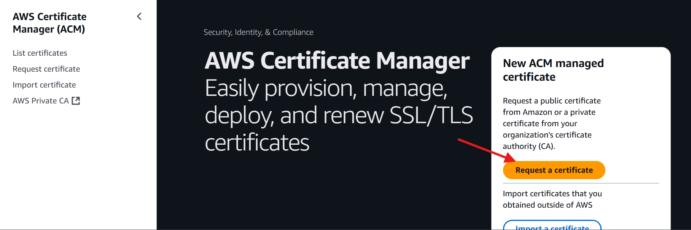

* + And request a certificate specially on region in **us-east-1.**
  + And wait for few minutes the issue will appear.

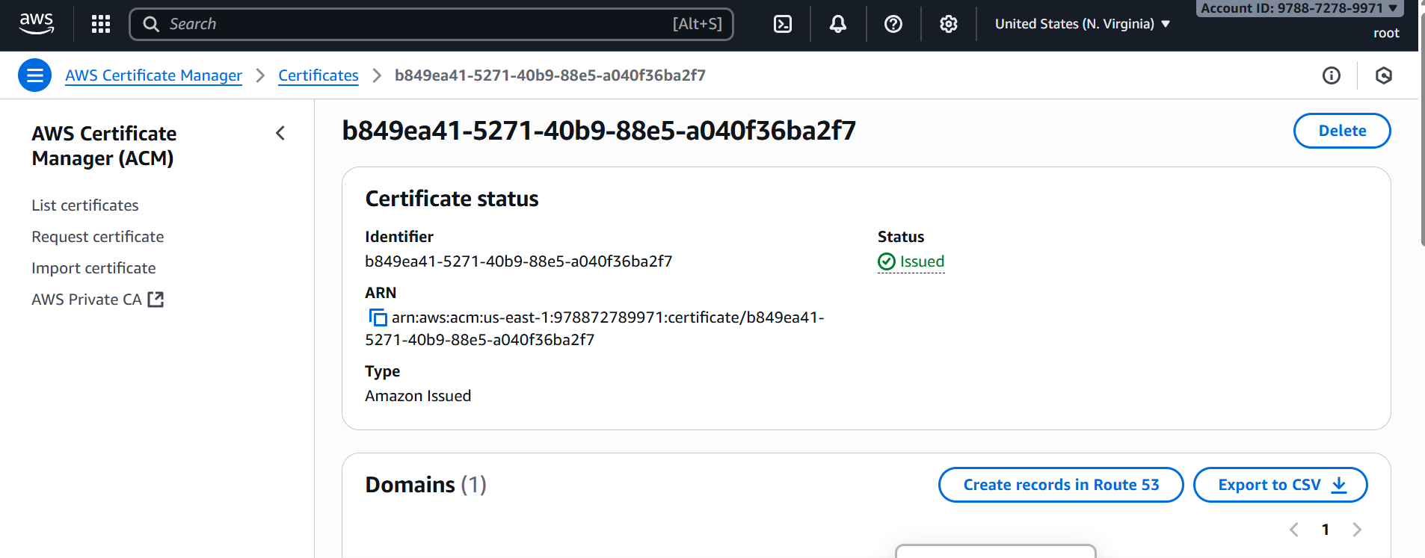

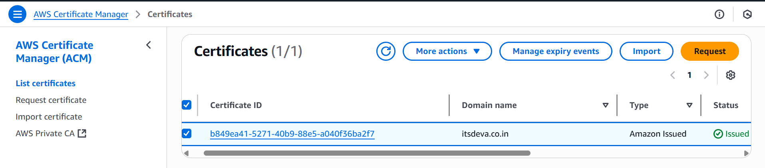

* + Go to **cloud Front**.
  + Click on **create a cloud Front distribution**

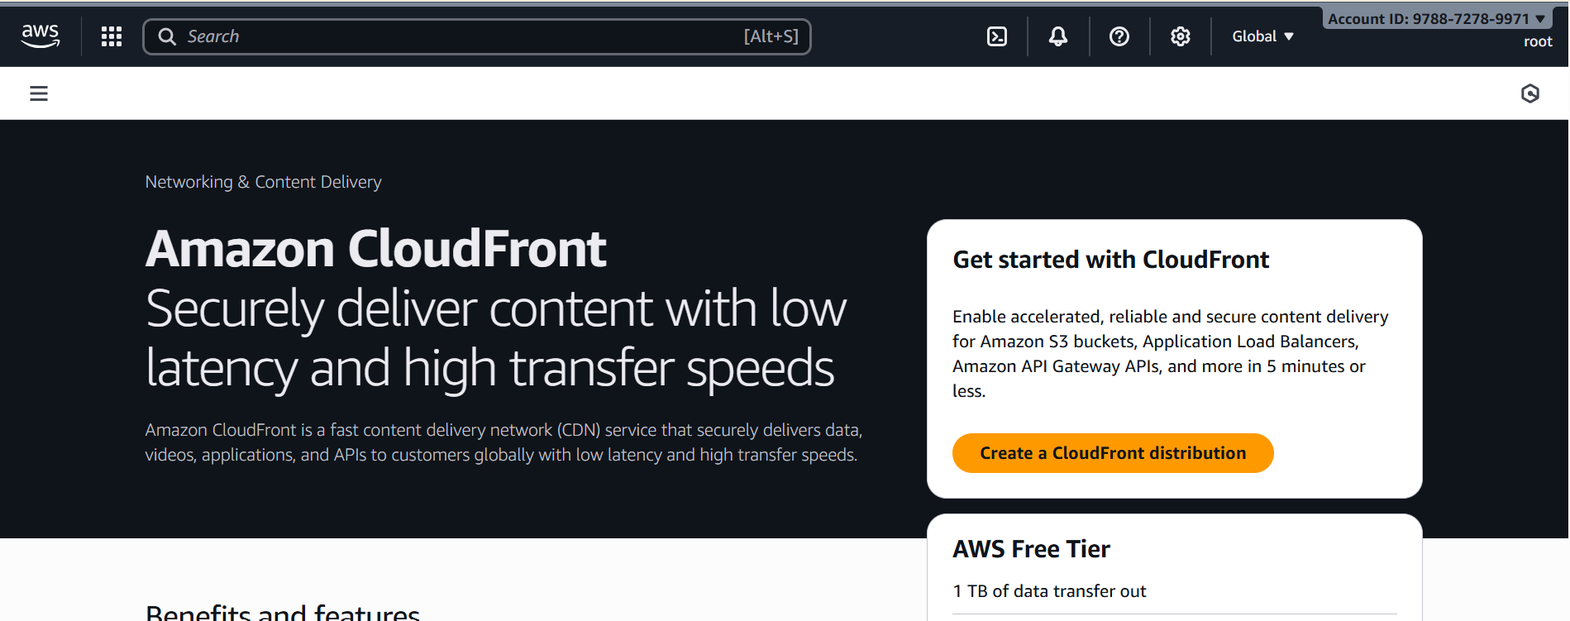

* + Give Distribution name
  + Select custom domain optional

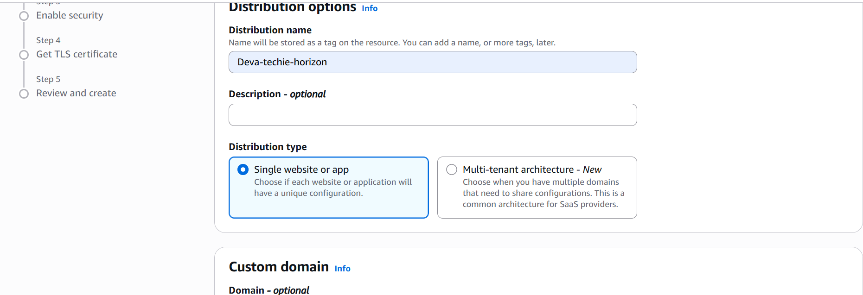

* + Select origin type (Amazon s3)
  + Give s3 origin
  + Click on **custom cache settings**
  + Select **viewer protocol policy** 🡪 **Redirect HTTP to HTTPS**
  + And leave ail fields default.

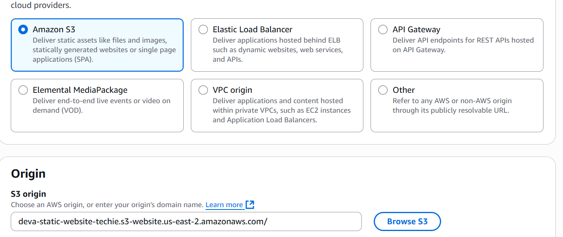

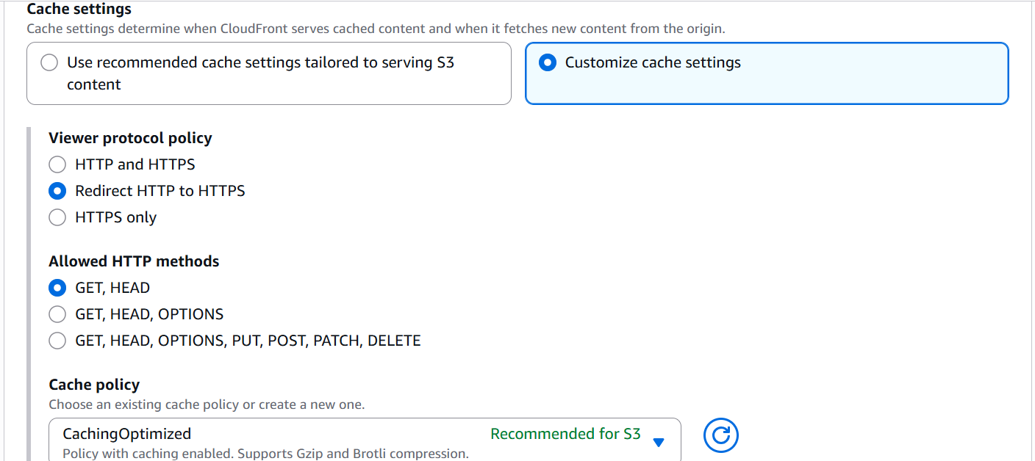

* + Select **web application firewall** **(**Do not enable security protections**)**

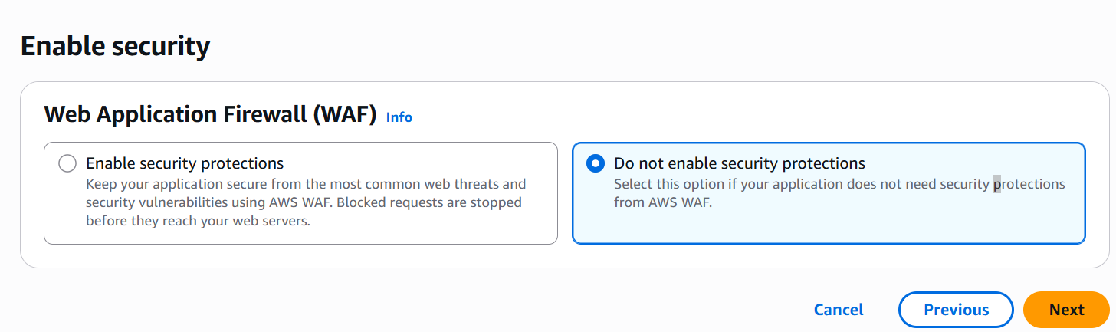

* + Click on next and create one distribution.

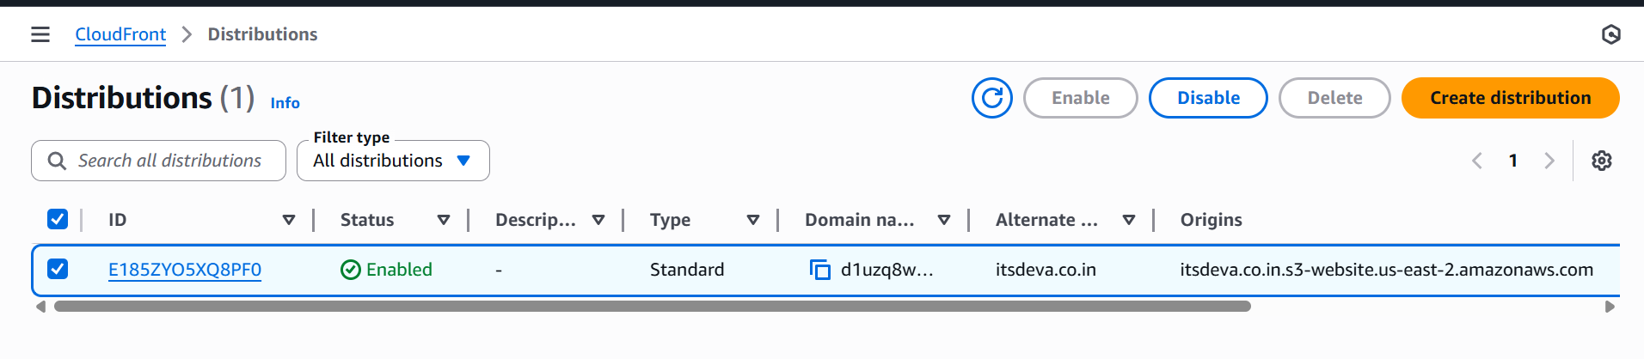

* + Then check record n cloud front.
  + If it’s not created create a one record in cloud front.
  + Then upload two files which is index.html and error.html
  + Make sure it should be on public.
  + Then copy the url from bucket properties

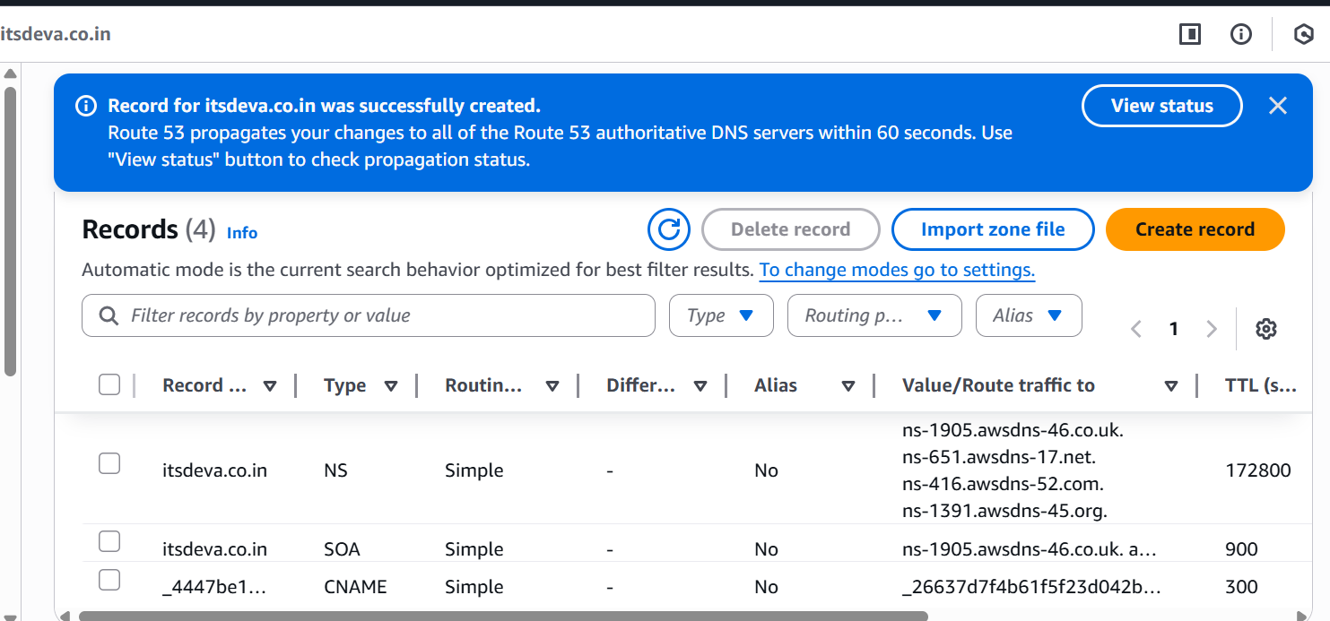

* + Go to cloud front and copy the **distribution domain name**
  + Go to browser and paste the url and check

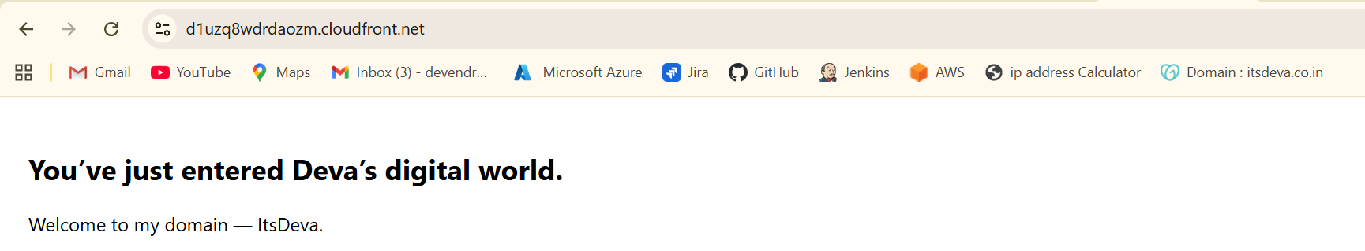

1. **Create a Route 53 hosted zone and map the domain with the CDN.**
   * Go to the **AWS** console
   * Then go to the route 53 and creating record.
   * And it will give you a four websites and go to the go daddy website.
   * Where you purchase the domain in go daddy.
   * Open a website and edit DNS name servers.
   * Copy the four DNS websites.

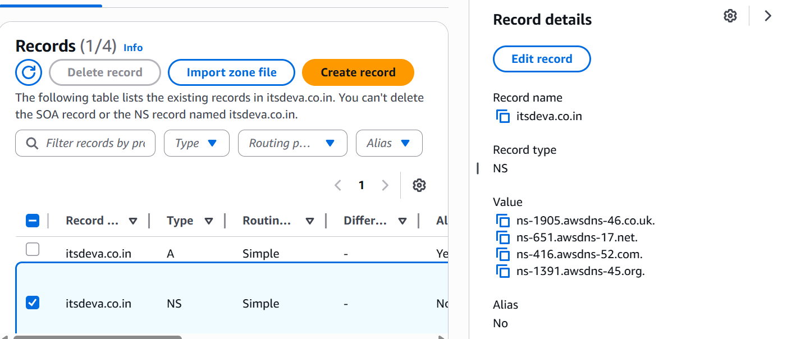

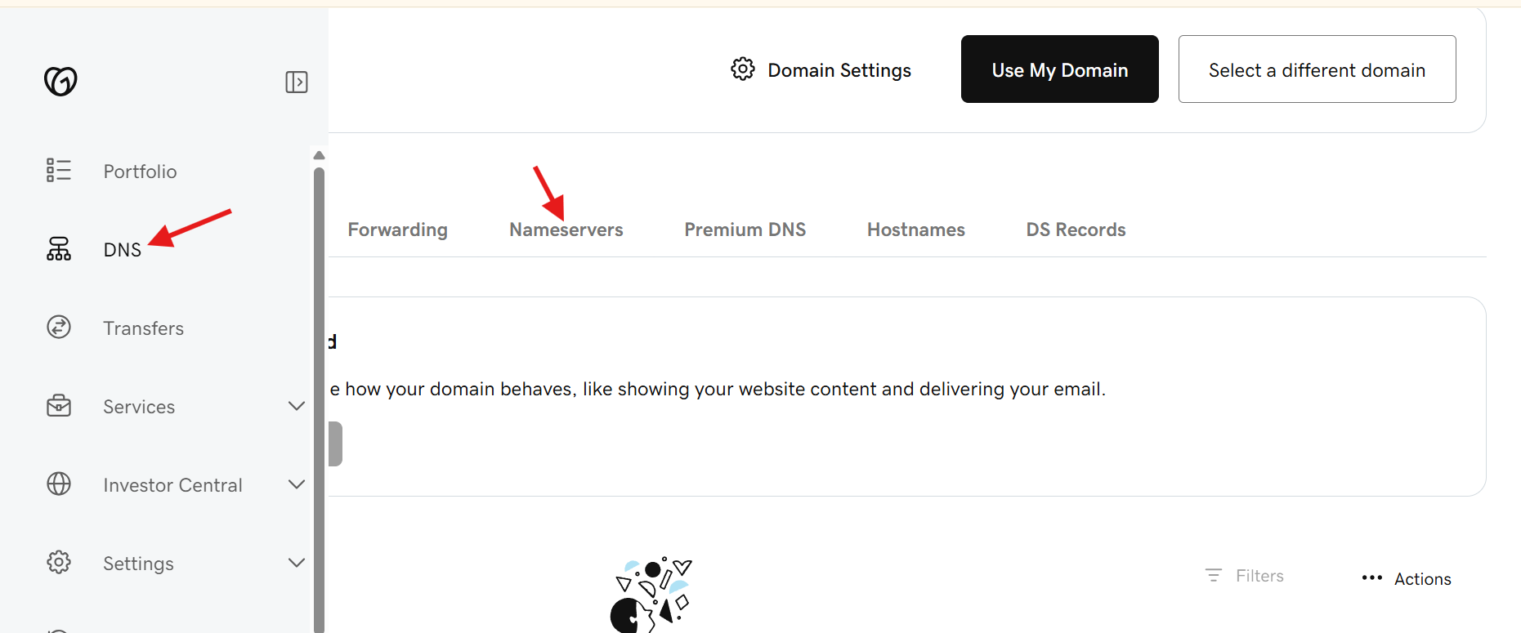

* + Server names in Go daddy.

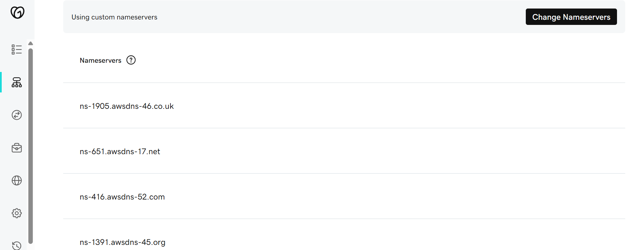

1. **Update the index.html in the S3 bucket and ensure the updated file is accessible using the domain name.**
   * Go to the cloud front distribution.
   * And copy the distribution domain name.
   * And paste it in the browser.

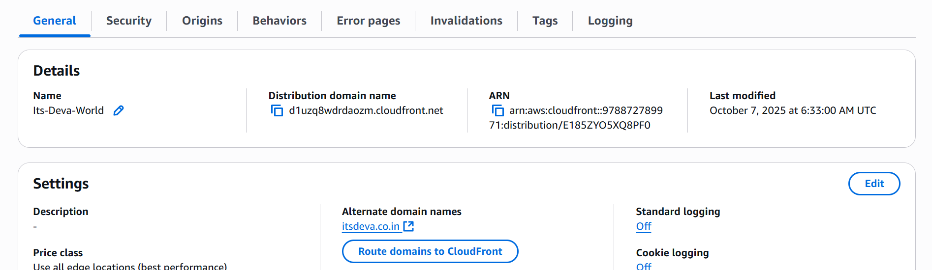

* + - Here is the result.

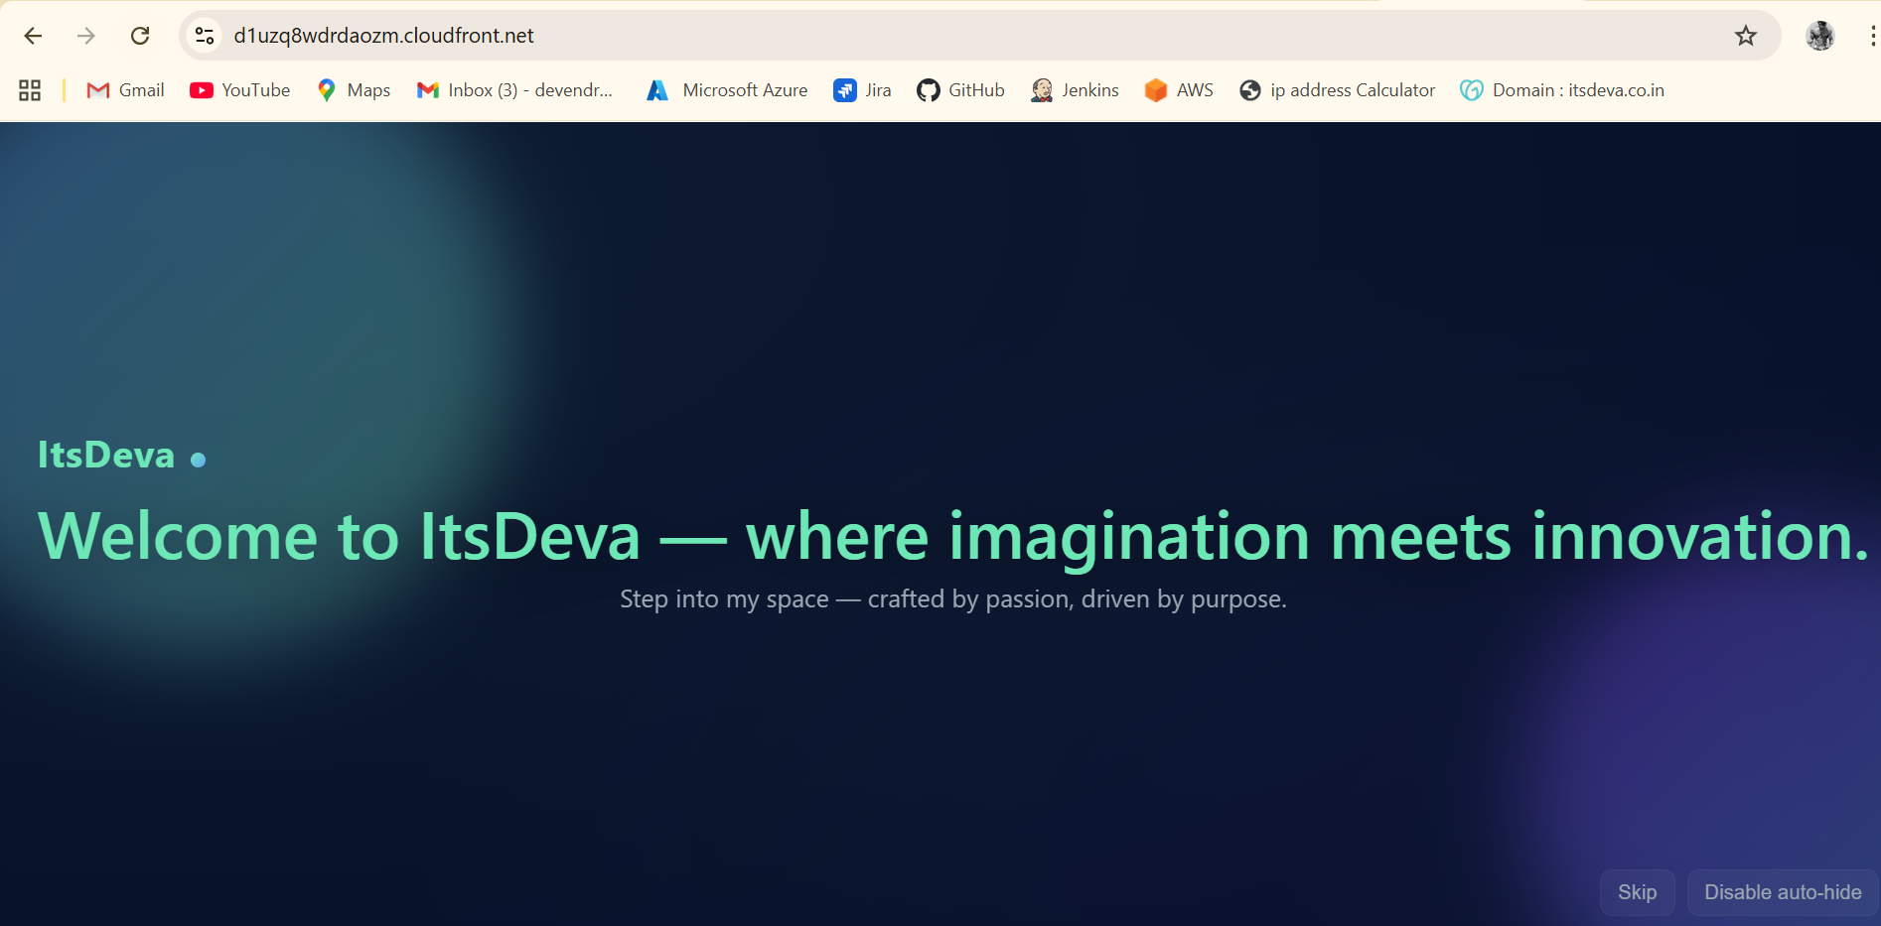

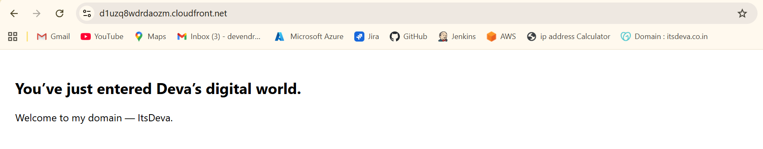

1. **Share the domain name in Slack to test the connectivity.**

[**https://itsdeva.co.in/**](https://itsdeva.co.in/)

